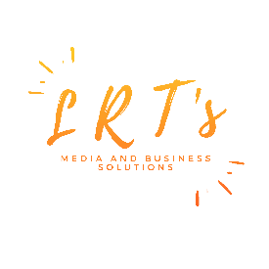
Article guide for LRT’s Media and Business Solutions Blog
“I4Development”
Dated: January 20th, 2024

- Articles must be 600-900 words in length written in Standing English.
- Submit articles in Word document
- Font recommended: Times New Roman 12.
- Include a brief bio of the author (50 words) and profile picture
- Include the Full name of author or co-authors, title, a brief summary with one to two sentence and no more than seven keywords for meta description. For example:
Name: John Doe
Title: Providing sustainable wastewater services in small island developing states
Summary: There is a greater need to promote long-term programmes to improve and expand the existing wastewater management services and facilities, as well as implement the institutional and operational reforms towards strengthening and improving the efficiency and cost-effectiveness of wastewater services in SIDs.
Keywords: water, wastewater, sustainable, pollution, SDG6, SIDs, islands

- In-text reference to other sites will be hyperlinked.
- End notes for articles/ data referenced is also accepted
- Articles must be accompanied by at least one high rez photo or video content with No copyright’s infringement, royalty free or free to use.
- Proof of permission maybe requested if needed
- Articles are allowed to cover a wide range of topics primarily linked to “development” understood as the delivery of product or services to better improve the lives of people.
- All articles will be given rights to the author with a by-line included.
- No monetary compensation will be provided.
- All articles must be submitted by Monday to lrtsmediaanbusinesssolutions@gmail.com in order to be published the following week.
- LRT’s Media and Business Solutions deserves the right to edit all content provided within the guidelines of the company’s operations. LRT’s Media and Business Solutions reserves the right not to publish or remove a published article as it sees fit.
- Disclaimer: The ideas reflected in the article is that of the author and does not represent the views or policies of LRT’s Media and Business Solutions. The company accepts no liability for the information produced or shared.
- Any queries can be directed to Mrs. Latoyaa Roberts-Thomas, Managing Consultant at lrtmediaandbusinesssolutions@gmail.com

